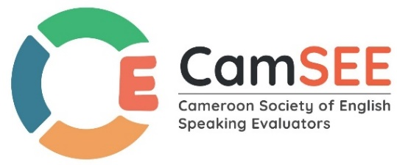
Cameroon Society of English-Speaking Evaluators
(CamSEE) Buea-Cameroon
Email: cameroonevaluators.eng@gmail.com
Email : info@cam-see.org
website: ww.cam-see.org
Phone numbers: 674578868/675987723
04/03/2024

The Independent Election Commission
African Evaluation Association

Dear Sir/Madam,
SUPPORT LETTER

I am writing on behalf of the Cameroon Society of English-Speaking Evaluators (CamSEE) to offer our full support and enthusiastic endorsement for Mrs. Mokake Mercy Ngala in her candidacy for the esteemed position of Vice President of the African Evaluation Association (AFrEA). It is with great confidence and pride that we recommend Mercy for this important leadership role in AFrEA.
Mercy has been an integral part of our evaluation association for 3 years as vice president, during which she has consistently demonstrated exemplary leadership qualities, a genuine passion for fostering growth and excellence within our community. Her tireless efforts and unwavering commitment to our organization's goals have not gone unnoticed, and we believe that she is well-suited to serve as Vice President of AFrEA. Throughout her tenure with CamSEE as Vice President Mercy has exhibited exceptional leadership skills, strategic thinking, and a collaborative spirit that have been instrumental in advancing our organization's mission and vision.
In conclusion, we believe that Mercy is qualified and deserving of the role of Vice President within AFrEA. Her proven track record of service, leadership and dedication make her an ideal candidate for this important position, and we are confident that she will bring vision, energy, and innovation to the role.

Sincerely,
Mr. Ngangeh Chrisogonous Tank
Deputy Secretary General
Cameroon Society of English-Speaking Evaluators (CamSEE)

